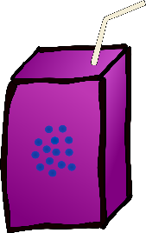

I’m embracing the silence because it’s nearly half eight,
The teachers are relaxing and feeling pretty great.
Then WHAM the doors open, all the children are back
Come on Mr F, you can do this, you just have to order snack.
Crumpet or toast with juice or a milk, it’s really a simple question;
But it’s actually getting an answer that causes the complication.
Paige arrives first, but soon gets lost, in her pictures and little doodles.
Miss Morris can’t help because she’s dreaming of dogs, like Chihuahuas, Pugs and Poodles.
There’s never an order from Jayden, as he always brings his own fruit
Dan’s rocked up and found a football and is getting ready to shoot.

Luke’s too busy researching aliens and is intensely looking for proof;
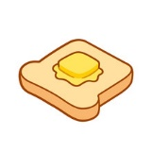
I can’t find Kevin, I can’t find Kevin, I think he’s up on the roof.
Leelas on top of a table, and is shouting at the top of her voice
Whilst Alex is making me guess again, he must be spoilt for choice.
Logan’s performing a magic trick and Ethan is day dreaming of home time
Zack is telling Miss Foster, the molecular structure of an enzyme
Indianna’s too busy sorting her next day trip and Ruby just has the giggles
Arthur is doing a very odd dance singing his money don’t jiggle jiggle
Michael is trying to hack a computer; Olly still can’t Log into his IDL
Lucas is off playing Star Wars where’s Tommy Joe? ‘oh look he’s fell’
Mia and Poppy are doing Tic Tok dancing, Ethan’s stole the teacher’s chair
Ruby and Grace draw Manga cartoons, whilst hiding behind their long hair
Isaac just casually throws a ball in the air as Charlie tells another classic story
Then finally, I just got an order hail Benjy in all of his glory
Haydn arrives like a tiny tornado, while Zainab shows off her new henna
It’s only been 4 and a half minutes this really is a dilemma
But then, through the door, a giant among kids she'll help me out of this pit
It’s Alice my saviour, ‘will you please do the snack, I really don’t think I can take it?’
Then finally it’s done, I’m completely exhausted and already wanting my bed.
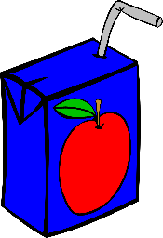
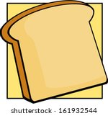
I get to the kitchen, pass over my sheet to be told that we’ve ran out of bread

