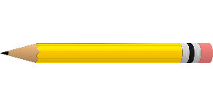

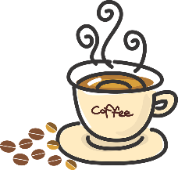

A Buttery Potion
This Photo by Unknown Author is licensed under CC BY-SA

Huddle snuggle spoil and cuddle, Mrs Butters is retiring, we’re all in trouble.
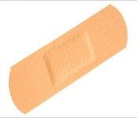

Add to the cauldron from up above,
This Photo by Unknown Author is licensed under CC BY-NC-ND
Thirteen years of genuine love.
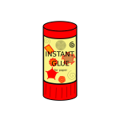
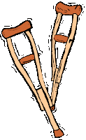
Four Fred fingers and a pencil,
Hot black coffee is essential.
Half a box of free school fruit, two footballs and a parachute.
Countless playtimes, three thousand plasters,
One broken ankle, slight disaster.
Mix in support and unwavering patience,
A dollop of humour, a slice of greatness.
A chunk of big cheese, an egg and spoon race,
Enough reading records to break a bookcase
Scoop in loyalty and a pinch of glue stick,
A glug of REALLY poor taste in music.
Sprinkle in a seasonal hamper,
a cup of laughs, a spoon of banter.
Half an hour from any school trip,
Sieve in memories and endless friendship.
One more thing to make this potion,
infinite amounts of complete devotion.
Let it simmer until it thickens,
One golden rule we don’t use chickens.

